

Holiday Meals List
Now – Dec. 24, 2025 * Update Daily at www.amamedia.org

Source: https://www.facebook.com/groups/366181894362307

Also Please sign up the Toys for Tots List ASAP, spots filled out soon!!!

Date | Event Flyers
2025-11-20 (Thursday) | 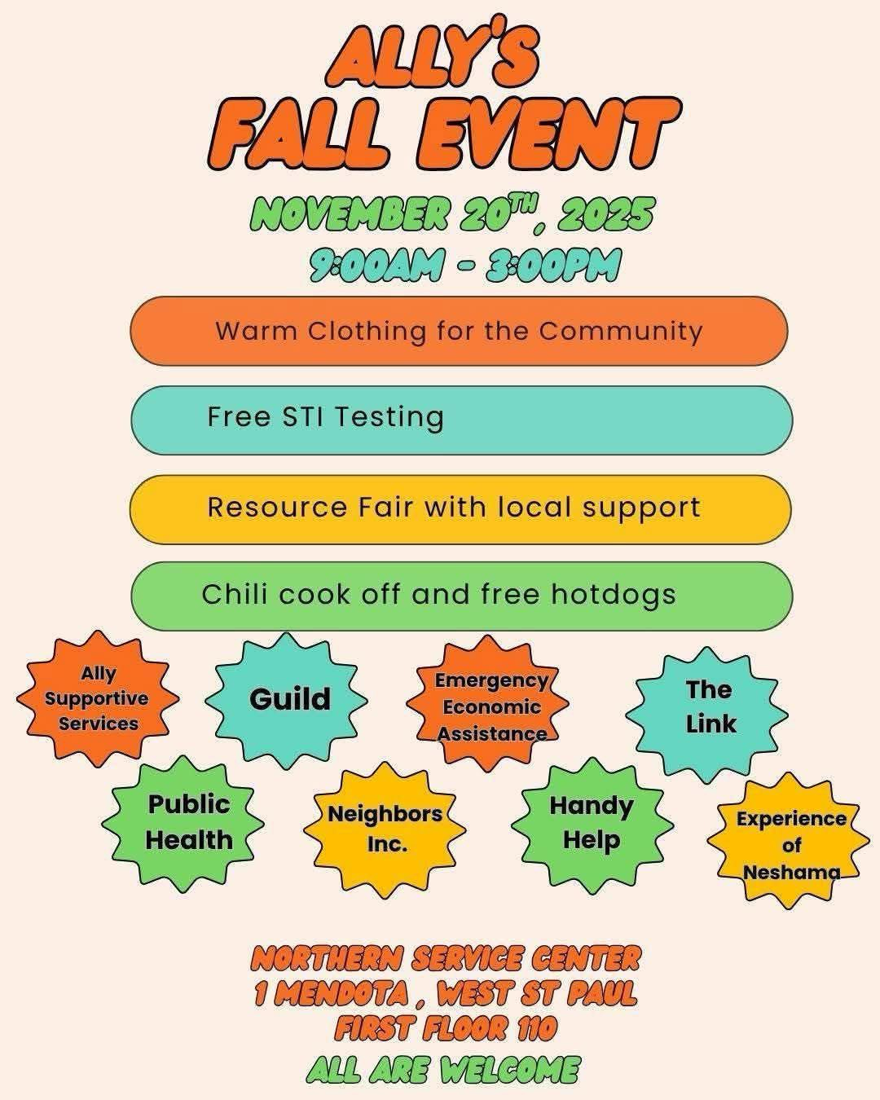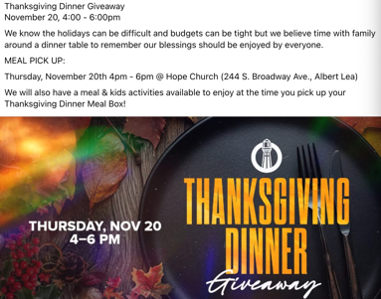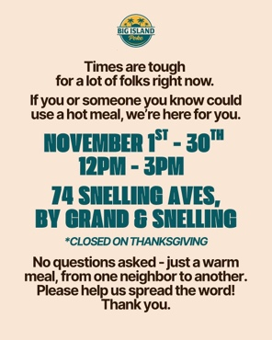
2025-11-21 (Friday) | 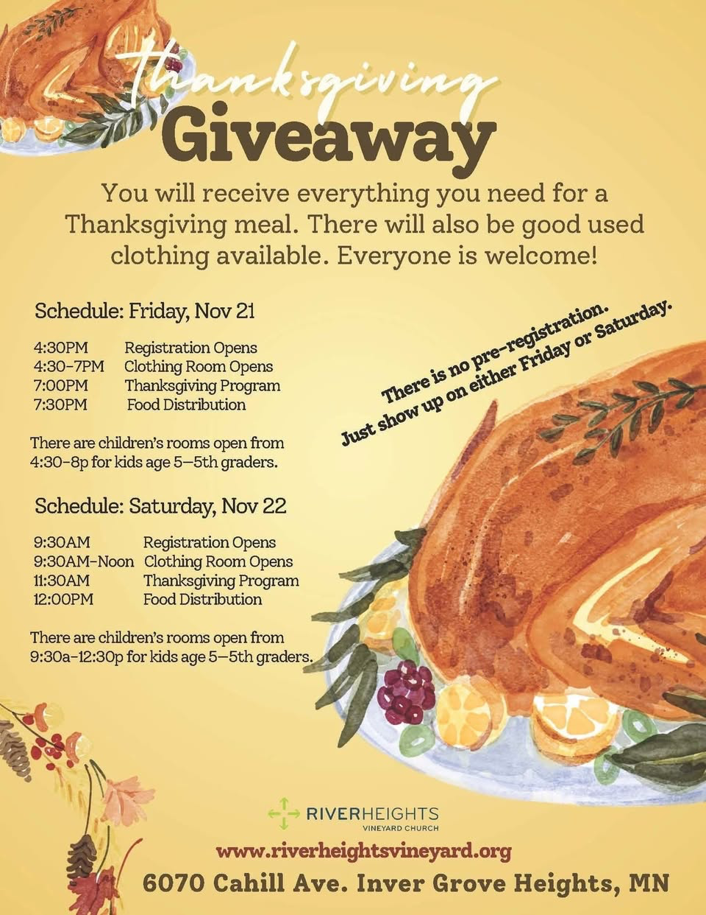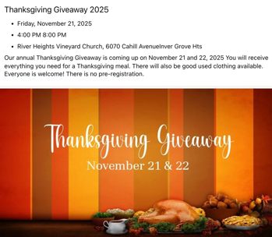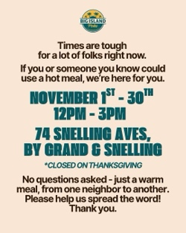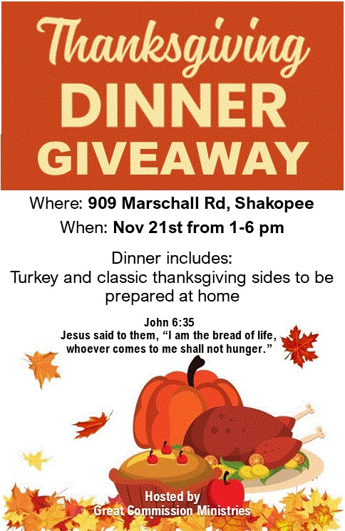
2025-11-22 (Saturday) | 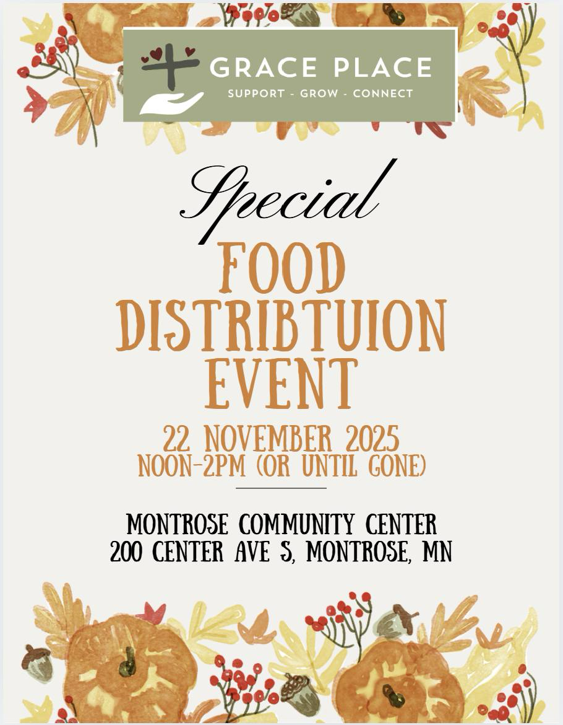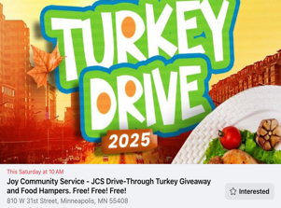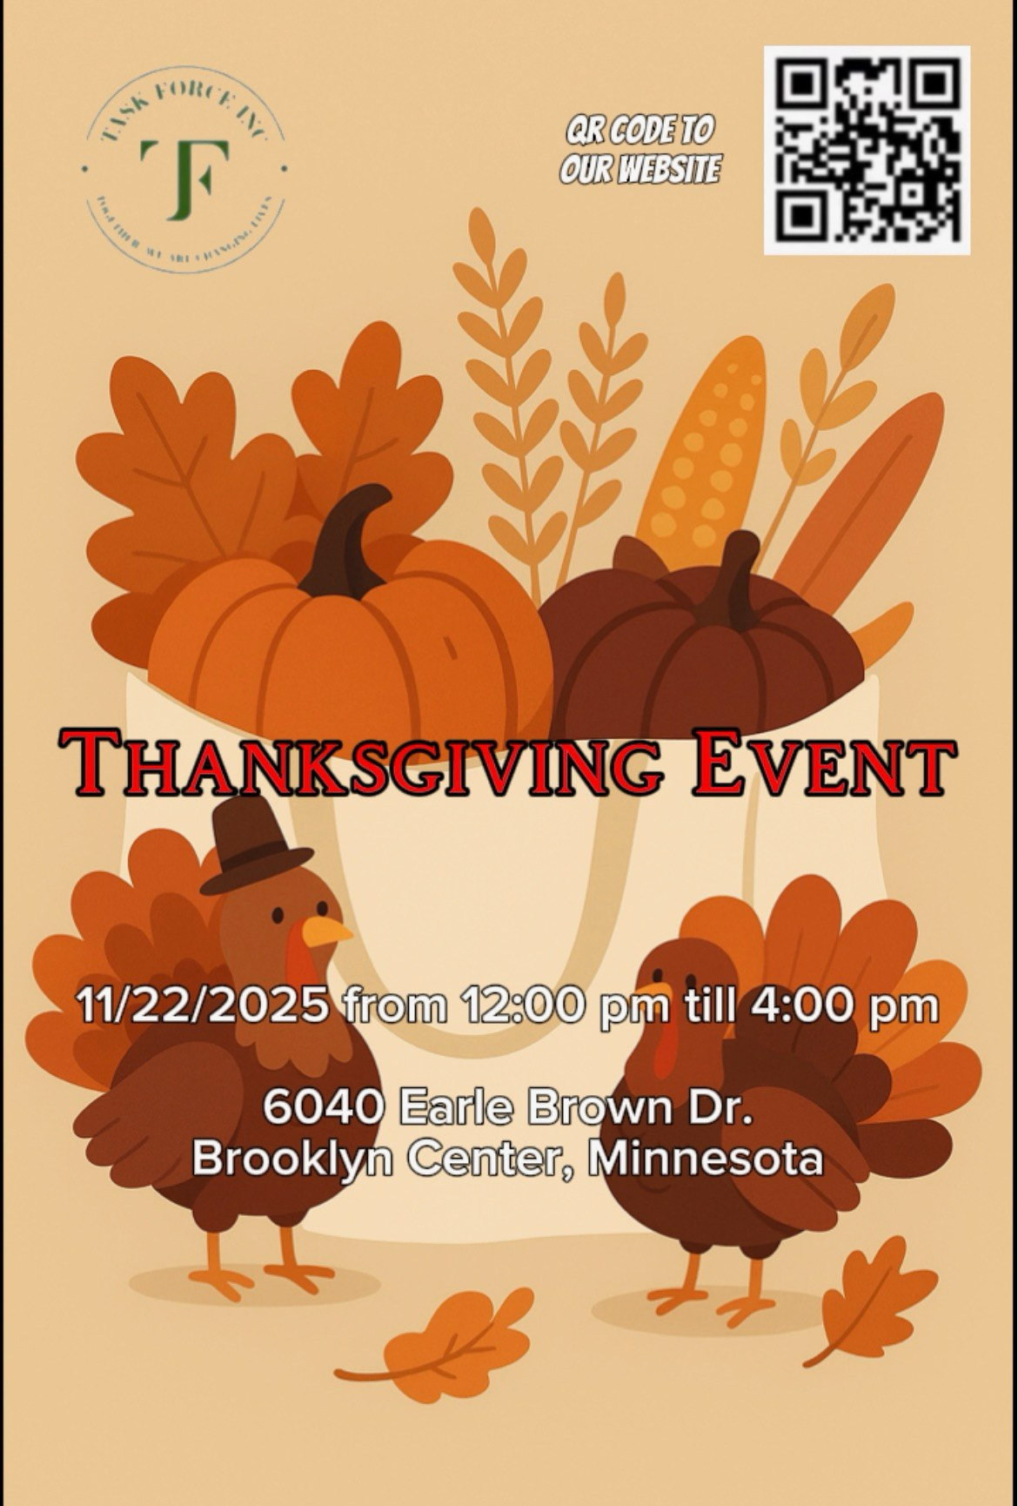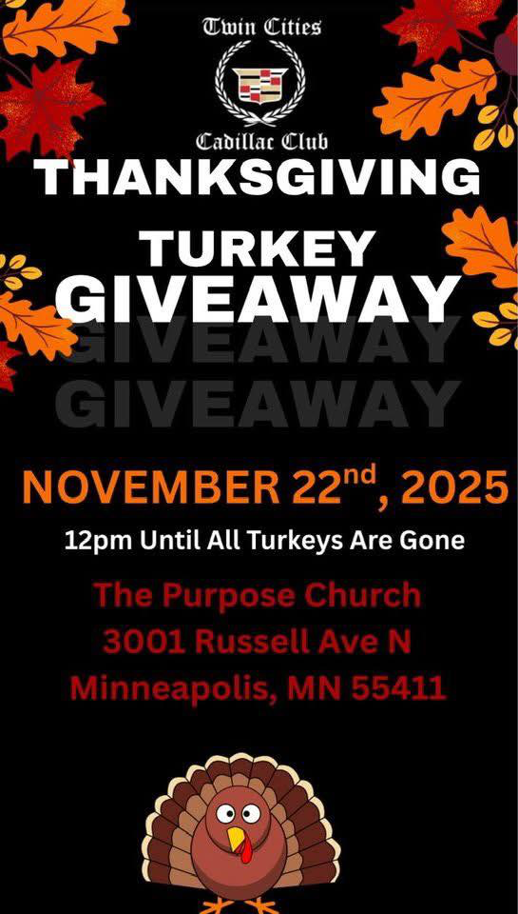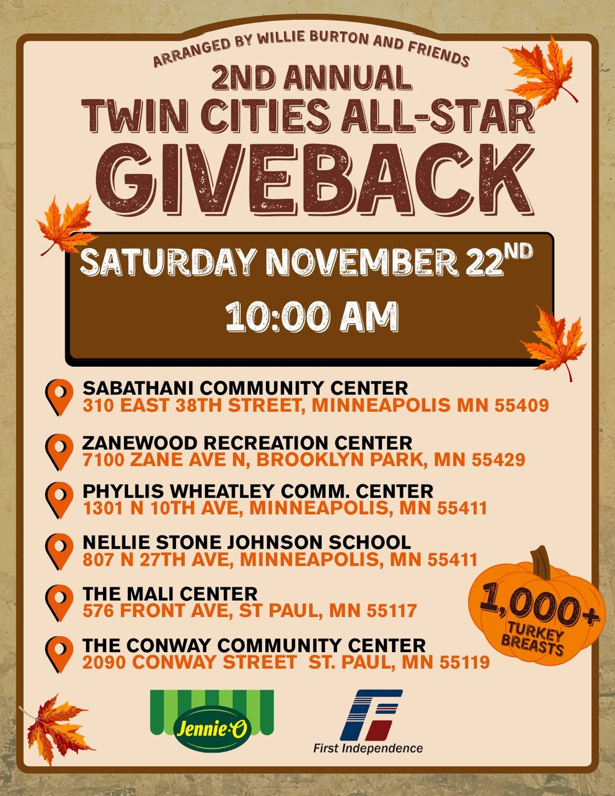
2025-11-23 (Sunday) | 
2025-11-24 (Monday) | 
2025-11-25 (Tuesday) | 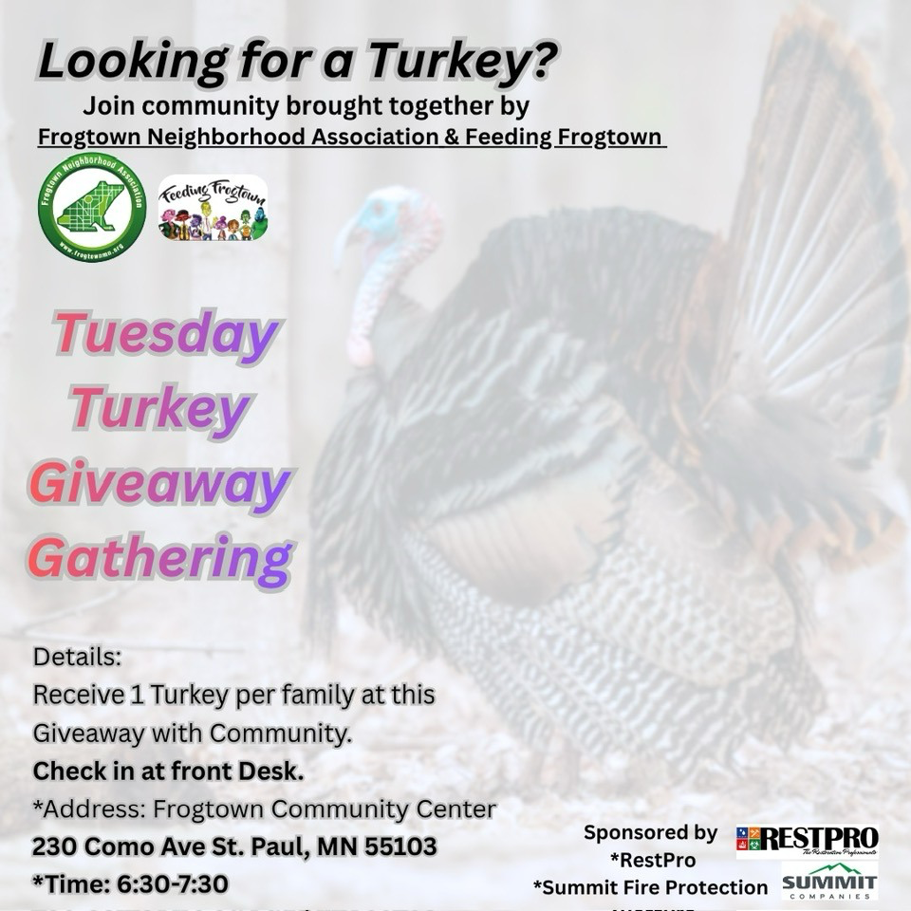
2025-11-26 (Wednesday) | 
2025-11-27 (Thursday) | 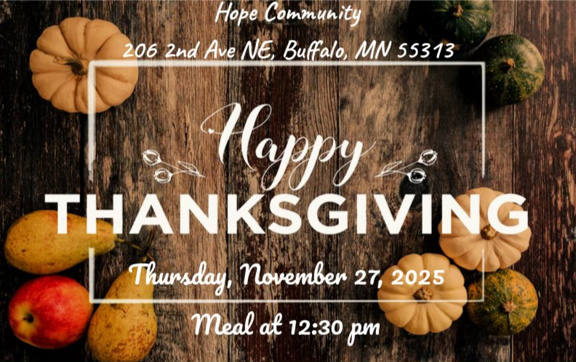
2025-11-28 (Friday) | 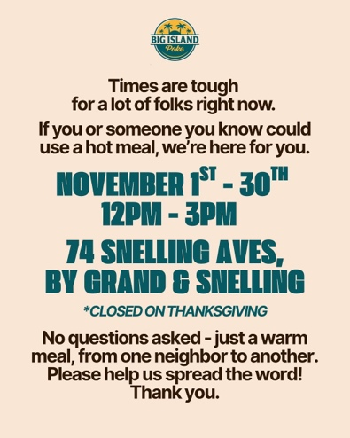
2025-11-29 (Saturday) | 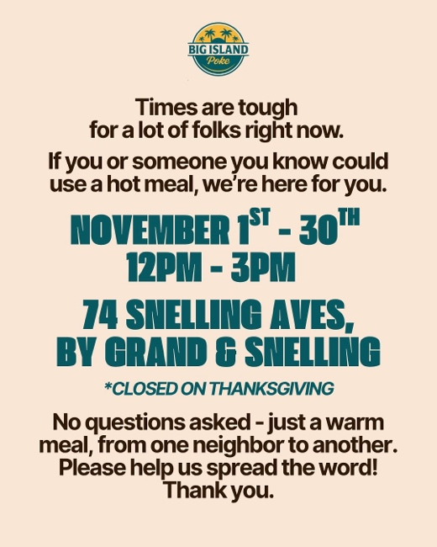
2025-11-30 (Sunday) | 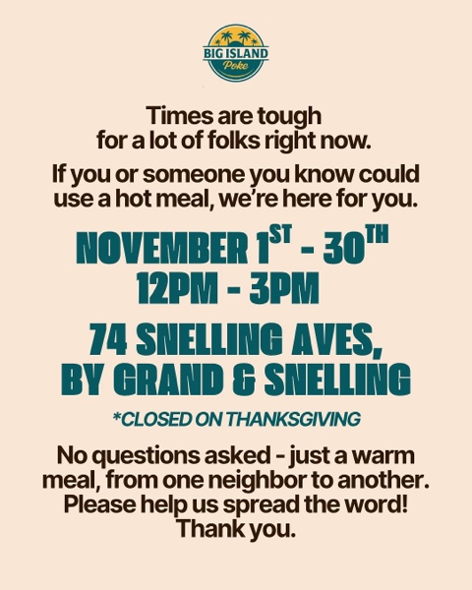
2025-12-01 (Monday)
2025-12-02 (Tuesday)
2025-12-03 (Wednesday)
2025-12-04 (Thursday)
2025-12-05 (Friday)
2025-12-06 (Saturday) | 
2025-12-07 (Sunday)
2025-12-08 (Monday)
2025-12-09 (Tuesday)
2025-12-10 (Wednesday)
2025-12-11 (Thursday)
2025-12-12 (Friday)
2025-12-13 (Saturday) | 
2025-12-14 (Sunday)
2025-12-15 (Monday)
2025-12-16 (Tuesday)
2025-12-17 (Wednesday)
2025-12-18 (Thursday)
2025-12-19 (Friday)
2025-12-20 (Saturday) | 
2025-12-21 (Sunday)
2025-12-22 (Monday)
2025-12-23 (Tuesday) | 
2025-12-24 (Wednesday)

